James Palmer

CS 362 – Winter 2017

Assignment 1

**You need to submit Assignment-1.pdf** **file to the Canvas (under assignemnt-1) that contains 5 pictures for different cards and provide an explanation for each card, such as cost, type, rules of each card. Choose 3 cards of your choice and Smithy and Adventurer are mandatory.**

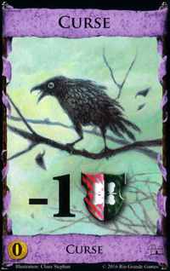

The first card is the curse card. In Dominion there is a scoring total called Victory Points. In the end of the game, the player with the highest total of Victory Points wins the game. However, if one player is pulling ahead of others, it is common to spend action cards that give a player a curse. On common way is using the Ambassador card to distribute curse cards. On the flip side, for a card such as Fairgrounds, it is possible to collect Curses for positive points. With a short note, how the game ends when three card piles are empty (or bought out), including the Curse pile. There is a strong strategy to buy all Fairgrounds and distribute all Curse cards to end the game. From a programming standpoint, a Curse negates 1 Victory Point from the player pool during the game.

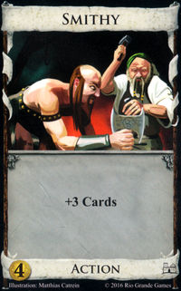

By default, you can play only one Action per turn unless other cards that have been played with + action. This card is self-explanatory. To buy this card you buy it with 4 copper to add to your deck. When played, you can draw three cards from your library, however, that uses your one action during your turn. There are no Victory points given from this card. From a programming standpoint, the player adds 3 more cards form their library more than the starting given five.

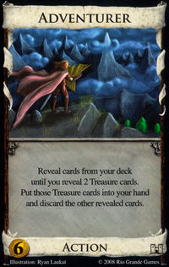

By default, you can play only one Action per turn unless other cards that have been played with + action. The Adventurer costs 6 Treasures to buy, which early on is a lot of treasure. This card is the definition of a randomly generated mechanic because you cannot manipulate the top of your deck. As stated, you reveal cards from your deck until you reveal 2 Treasure Cards (copper 1, silver 2 and gold 3). Then you discard the rest of your cards to your “graveyard.” This card can have great upside. If you are able to trash your copper Treasure Cards, you can constantly hit higher Treasure cards (say revealing two Gold Treasures for 6 buy). From a programming side, it seems more difficult to differentiate between adding only the first two Treasure cards and discarding all other cards “revealed” without “drawing” said cards.

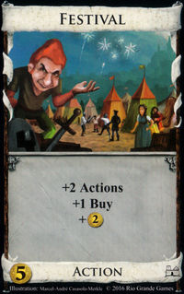

This is probably my favorite card in the basic dominion game because it generates the most value of any other card. It cost 5 Treasure to buy and has three lines of text. It counts as your first Action per turn, however, it adds +2 action to your pool, allowing the player to play two more Actions following Festival. Second, it allows you to buy more than one card per turn. By default, you are only allowed to buy one card, unless you play cards like Festival. Then for extra value, you are given +2 Treasure to your pool. This card is the definition of value. It is common for a player to have two Festival cards followed by two smith cards (draw +3 cards per smith card) to generate a high amount of Treasure and buy more than one card. From a programming view, it is simple to add +2 Actions, +1 Buy and +1 Treasure to a players turn.

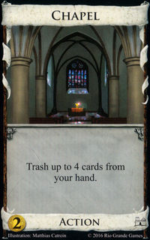

Chapel is a card that cost two Treasures to purchase. The mechanic “Trash” is you can remove cards from your deck from the game forever. In Dominion, when you have no more library to draw from, you shuffle your graveyard and that becomes your library. With Chapel, you can remove pesky cards that you do not want to draw such as coppers. What is important, is Chapel says “up to 4 cards.” That means you do not have to Trash any cards from your hand if you do not wish to. Also, you can Trash other Chapel cards that are in your hand, it cannot Trash itself when played. This card is used to thin your deck of terrible cards in room for better cards. From a programming standpoint, I would just have a function to permanently remove the card identity from your deck.